
PROJECTILE TRAJECTORY INVESTIGATION Name:_________________

BACKGROUND: Projectile motion is another example of two-dimensional motion in a plane! In this case, the two dimensions are vertical (up and down) and horizontal (forward and back). In this simulation, you will investigate key aspects of projectile motion.

You are a member of the LASS Science Olympics Team and are competing in the Catapult Competition. If your catapult launches a golf ball the farthest distance, the LASS team wins!! The question is, at what angle should you launch the golf ball to achieve the maximum distance for the given launch speed?

You will be investigating the following questions:
1) For a given launch speed, what launch angle will produce the maximum horizontal range?
2) How does maximum height achieved vary with launch angle for a given launch speed?
3) Can different launch angles achieve the same target distance for a given launch speed?

YOU MAY WORK IN PARTNERS AS YOU DISCUSS RESULTS, BUT EACH PARTNER MUST WRITE UP THE ANALYSIS QUESTIONS IN HIS OR HER OWN WORDS!!
Please complete the simulation on separate paper!

Part A: Hypothesis [2 marks]
Make a prediction regarding what launch angle will produce the maximum horizontal range for a projectile launched from level ground and landing back on level ground. Provide reasoning to support your hypothesis.

Simulation Investigation
- Open Google and type in “physics classroom projectile motion simulator”
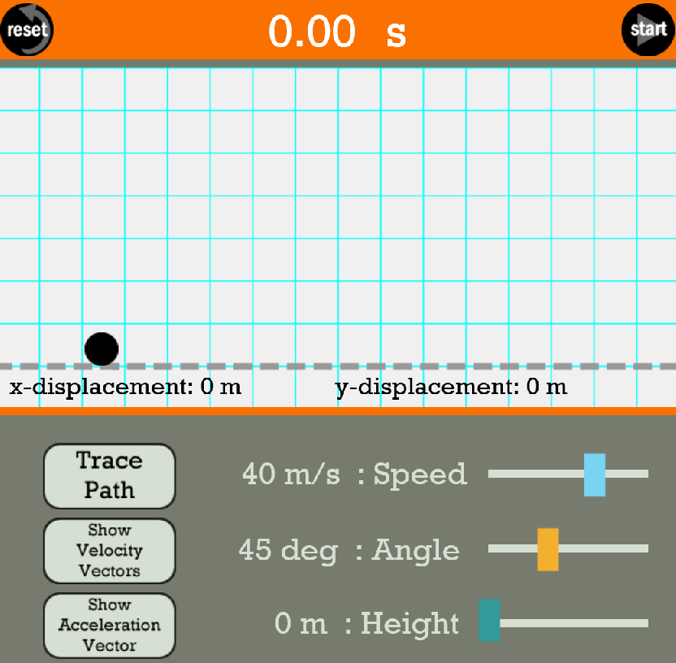
- When you get to the Projectile Simulator screen, click on “Launch Interactive” then “Launch Tool”

You should see the following screen:

• Choose an initial launch velocity between 40.0 m/s and 50.0 m/s.
• To run the simulation hit “Start”. Hit “Reset” to reset the path to the initial state.

1) Introductory Activity: Examining Velocity Vectors [4 marks]
- Run the simulation several times with a set launch velocity and set angle (e.g. 50.0 m/s with a launch angle of 35°). Turn on the Trace Path and Show Velocity Vector options. We will set the horizontal direction as x and the vertical direction as y.

Discuss how the Vx and V_{y} vectors vary during the projectile travel for a given launch
angle and speed. Explain the variation you see.

- Hit Reset. Without launching the projectile, play around with the Angle slider. How do the initial magnitudes of the Vx and Vy vectors change as you change the launch angle? Please discuss your observations.

- Running the simulation for various launch angles: For the remaining simulation, keep the launch speed constant for all trials! Vary the launch angle to vary between 10.0° to 80.0° in 5.0° steps. You will need to PAUSE the path at the peak to record the maximum height reached. [ 3 marks]
Table 1: Projectile Path Parameters Launch Speed:____________________
Launch  Angle (°) | Maximum Horizontal Distance (m) | Maximum Height  (m) | Total Time in Air  (s)
10.0
15.0
20.0
25.0
30.0
35.0
40.0
45.0
50.0
55.0
60.0
65.0
70.0
75.0
80.0
Chart Complete with appropriate Sig Digs recorded

4) a) Create a smaller chart with same headings to compare trajectory parameters for the following
paired sets of angles: [ 1 mark]
15° and 75°
30° and 60°

b) Below your chart, sketch and label the trajectories for the 30° and 60° launch angles. [ 1 mark]

Referring to your data tables to support your discussion, answer the following questions.

5) a) What trend did you observe for horizontal range as the launch angle varied from 5 .0° to 85.0°?
[1 mark]

b) What trend did you observe for time of flight as the launch angle varied from 5 .0° to 85.0°?
[1 mark]

6) What did you observe about the projectiles launched at the same speed but at complementary
angles (eg. 30° and 60°). Explain why this information would be useful if you needed to hit a
particular target distance with a projectile over hilly landscape. [2 marks]

7) What launch angle provides the maximum horizontal range for a projectile launched at a given
speed? Discuss how this result compared with your prediction. [2 marks]

Part D: Final Summary
Summarize what you learned about the nature of projectile motion from this investigation. Include a discussion of velocity vectors, launch angle, projectile range and projectile maximum height in your summary. [3 marks]

Inquiry:
Charts and Question Completion _____/ 20 marks

Communication: Level: _________
• Thorough explanations
• Supporting data provided in explanations
• Explanations are written in full sentences with correct spelling and grammar
• Appropriate precision in recorded values

